Solutions to Selected Problems in Assignment 1:

3. (a) P(34 < X < 50) = P(– 1.33 < Z < 0) = 0.4082
(b) P(34 < X < 38) = P(– 1.33 < Z < – 1.00) = 0.1587 – 0.0918 = 0.0669
(c) P(X < 30) + P(X > 60) = P(Z < – 1.67) + P(Z > 0.83)
= 0.0475 + (1.0 – 0.7967) = 0.2508
- The standard error of the sample is 3 [12/sqrt(16)].
P(X_{bar} < 45) = P[Z < (45-50)/3] = P(Z < -1.67) = 0.0475
- The population must be normally distributed because the sample size is less than 30 and the sample must be randomly selected.

4 (a) H₀: $m$ = $160. The average amount of cash withdrawn per customer from the ATM machine is equal to $160.
H₁: $m¹$ $160. The average amount of cash withdrawn per customer from the ATM machine is not equal to $160.
Decision rule: Reject H₀ if Z < – 1.96 or Z > + 1.96.
Test statistic: $Z=\frac{\bar{X}±m}{s\sqrt{n}}=\frac{\$\text{172}±\$\text{160}}{\$\text{30}\sqrt{\text{36}}}$ = 2.40
Decision: Since Z_{calc} = 2.40 is greater than the upper critical bound of 1.96, reject H₀. There is enough evidence to conclude that the average amount of cash withdrawn per customer from the ATM machine is not equal to $160.

p-value = 0.0164

(b) Decision rule: Reject H₀ if Z < – 2.58 or Z > 2.58.
Test statistic: $Z=\frac{\bar{X}±m}{s\sqrt{n}}=\frac{\$\text{172}±\$\text{160}}{\$\text{30}\sqrt{\text{36}}}$ = 2.40
Decision: Since Z_{calc} = 2.40 is between the critical bounds of Z = $±$ 2.58, do not reject H₀. There is not enough evidence to conclude that the average amount of cash withdrawn per customer from the ATM machine is not equal to $160.

5. (a)
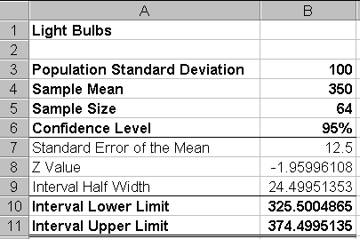

(b) No. The manufacturer cannot support a claim that the bulbs last an average 400 hours. Based on the data from the sample, a mean of 400 hours would represent a distance of 4 standard deviations above the sample mean of 350 hours.
(c) No. Since $s$ is known and n = 64, from the central limit theorem, we may assume that the sampling distribution of $\bar{X}$ is approximately normal.
(d) An individual value of 320 is only 0.30 standard deviations below the sample mean of 350. The confidence interval represents bounds on the estimate of a sample of 64, not an individual value.

